U.S. Radiocommunication Sector
Fact Sheet
Working Party: ITU-R WP 7C | Document No: US 7C/27-009NC
Ref.: XXXXX/Document 7C/49 | Date: 8 August 2024
Document Title: NON-CONSENSUS: Proposed draft reply liaison statement to Working Party 4C on WRC-27 agenda item 1.12
Author(s)/Contributors(s):  Daniel Bishop  NASA  Jason Szklany  ADS for NASA | Phone:  Email : Daniel.W.Bishop@nasa.gov  Phone:  Email: jszklany@asrcfederal.com
Purpose/Objective: To provide a draft reply liaison statement from WP 7C to WP 4C on system characteristics relating to WRC-27 agenda item 1.12.

Abstract: Working Party (WP) 7C is listed as a contributing group for WRC-27 agenda item 1.12 and is assembling relevant technical and operational characteristics for the conduct of studies on spectrum requirements, for non-GSO low-data-rate MSS systems, including mitigation techniques.
This contribution seeks to provide a draft reply liaison statement that includes relevant operational characteristics to be considered in their studies.
Non-consensus Status: Objections were raised to mention of the cold sky calibration function that passive sensors perform. The text is indicated in square brackets in Annex 1.
Fact Sheet Preparer: Jason Szklany
Radiocommunication Study Groups | 
Source: Document xxxxxxxx  Subject: WRC-27 agenda item 1.12 | Document XX/-E
 | Date 21 May 2024
 | Original: English
United States of America
proposed reply liaison statement to working party 4C regarding WRC-27 agenda item 1.12
The Administrative Circular CA/270 identifies Working Party (WP) 4C as responsible group and WP 7C as a contributing group for WRC-27 Agenda Item 1.12 which calls for studies on potential new allocations to, and regulatory actions for, the mobile satellite service in the frequency bands 1 427-1 432 MHz (space-to-Earth), 1 645.5-1 646.5 MHz (space-to-Earth) (Earth-to-space) 1 880-1 920 MHz (space-to Earth) (Earth-to-space) and 2 010-2 025 MHz (space-to-Earth) (Earth-to-space) required for the future development of low-data-rate non-geostationary mobile satellite systems.
In document 7C/49, WP 4C requested relevant technical and operational characteristics and protection criteria for the frequencies listed above. This document proposes a draft liaison statement that contains any characteristics and criteria to be sent to WP 4C in support of any necessary studies on agenda item 1.12.

Attachment: 1.

Attachment
Working Party 7c
proposed reply liaison statement to working party 4C regarding WRC-27 agenda item 1.12

Working Party (WP) 7C thanks WP 4C for its liaison statement in Document 7C/49 seeking relevant technical information to support studies under WRC-27 agenda item 1.12. In the frequency bands identified for consideration under Resolution 252 (WRC-23) for WRC-27 Agenda Item 1.12, there is an Earth exploration-satellite service (EESS) (passive) allocation in the following band:
- 1 400-1 427 MHz: This band is subject to RR No. 5.340 (all emissions are prohibited) and is adjacent to the 1 427–1 432 MHz frequency band under consideration. Information pertaining to systems operating in this adjacent allocation is located in Annex 1.

Working Party 7C appreciates being kept informed of the status of all studies regarding EESS systems under this agenda item and looks forward to collaboration on other WRC-27 agenda items.
Status: For information and action, if any
Contacts: xxxxxxx xxxxxxx  Xxxxxxx xxxxxxx | E-mail: xxxxxxxxxxx  E-mail: xxxxxxxxxxx
______________

Annex 1
Information pertaining to EESS (passive) allocations in the
1 400-1 427 MHz frequency band.

Interference criteria
The EESS (passive) interference criterion in the 1 400-1 427 MHz frequency band is given in Table 2 of Recommendation ITU-R RS.2017-0, as a value of –174 dBW/27 MHz associated with a 0.1% of time it may be exceeded in a measurement area of 10 000 000 km².

System Parameters
Recommendation ITU-R RS.1861-1 provides technical and operational parameters of EESS passive systems including descriptions of sensor scanning configurations. Table 1 is taken from this Recommendation and represents typical system parameters for the 1 400-1 427 MHz frequency band. Additionally, Recommendation RS.1861 includes antenna patterns for sensor types A1 and A2 which are shown in figure 1 and figure 2 respectively. For Sensor type A4, the sensor antenna pattern is modeled using Recommendation ITU-R RS.1813-2. [Sensor A4 additionally relies on a calibration process performed while the antenna’s mainbeam is focused away from the Earth’s surface. During this time, the system performs a measurement of the cosmic background to obtain a “cold calibration”. Table 1 includes the dynamics of the sensor during this cold calibration process.]
TABLE 1
EESS (passive) sensor characteristics in the 1 400-1 427 MHz frequency band
 | Sensor A1 | Sensor A2 | Sensor A4
Sensor type | Interferometric radiometer | Conical scan | Conical scan
Orbit parameters
Altitude (km) | 757 | 670 | 820
Inclination (degree) | 98 | 98 | 98.702
Eccentricity | 0 | 0 | 0.0011441
Repeat period (days) | 3 | 3 | 29
Sensor antenna parameters
Number of beams | 1 | 1 | 1
Antenna size | N/A | 6.2 m | 7.4 m
Maximum beam gain (dBi) | 9 | 37 | 39.1
Polarization | V, H | V, H | V, H
−3 dB beamwidth (degree) | 71.6 | 2.6 | 1.89-2.20
Instantaneous field of view | 756 km² | 50.1 × 38.5 km | 77 × 43 km
Off-nadir pointing angle (degree) | 25 | 35.5 | 46.5
Incidence angle at Earth (degree) | 2°/48 | 39.9 | 55
Swath width (km) | 1 000 | 1 000 | >1 900
Antenna efficiency |  | 0.60
Beam dynamics | Fixed | 14.6 rpm | 7.8 rpm
Sensor antenna pattern | Fig. 9 | Fig. 10
Cold calibration antenna gain (dBi) | N/A | N/A | 39.1
Cold calibration angle (degrees re. satellite track) | N/A | N/A | 0 º
Cold calibration angle (degrees re. nadir direction) | N/A | N/A | 45º-180º
Sensor receiver parameters
Sensor integration time | 1.2 s | 84 ms | 55.4 ms
Channel bandwidth (MHz) | 27 | 27 | 27
Measurement spatial resolution
Horizontal resolution (km) | 40 | 39 | 77
Vertical resolution | N/A | N/A | 43 km

FIGURE 1
Sensor A1 antenna pattern for the 1 400-1 427 MHz frequency band
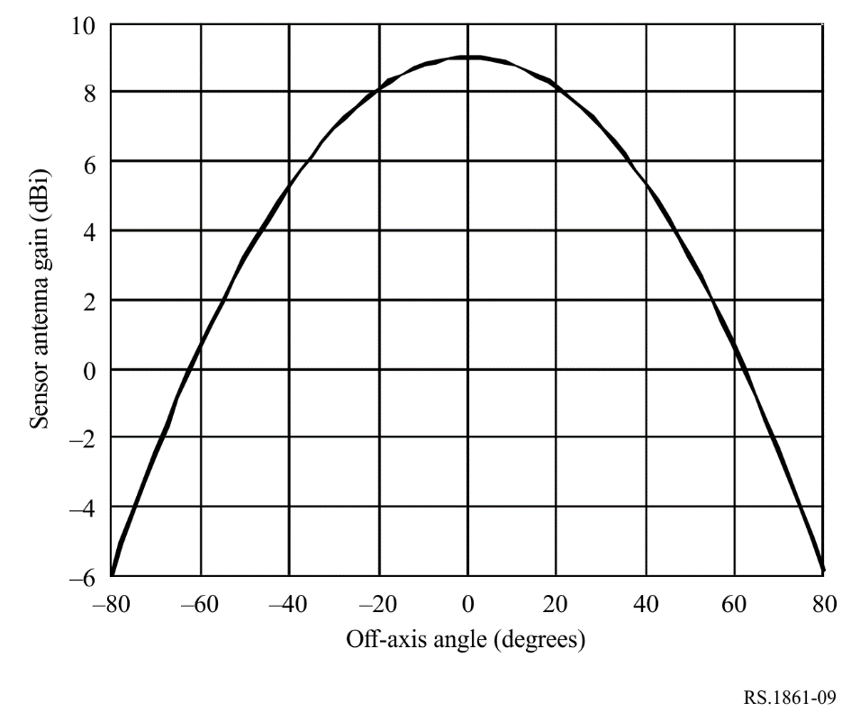
FIGURE 2
Sensor A2 antenna patterns for the 1 400-1 427 MHz frequency band
